Basics of Morphological Operations

Morphological operations are basic techniques to do image segmentation. It reduces the noise in the image by looking at neighboring pixel values instead of its own numerical values.

How does morphological operations work?

A matrix called “structuring element” is used to probe the image to compare all of its corresponding neighboring pixels.

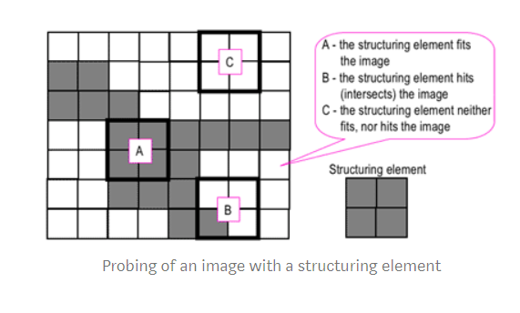

Looking at the image above, the structuring element probes the image and applies whatever the chose morphological operations the user inputs.

Basic Operations:

1. Dilation
   1. Acts as a local maximum filter meaning it expands the shape of the input image
   2. It adds a layer of pixels to the inner and outer boundaries of regions
   3. It makes an object more visible and fills in small holes in objects
   4. The value of the output pixel is the max value of all pixels in the structuring element

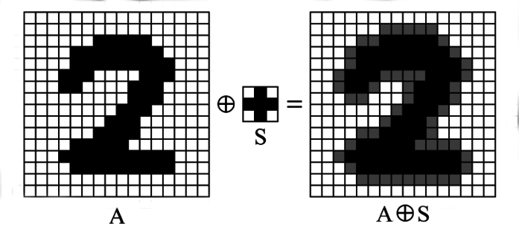

1. Erosion
   1. Opposite of dilation; it reduces the shape in the input image
   2. Acts as a local minimum filter
   3. Erosion helps eliminate the holes and gaps between different regions
   4. Value of the output pixel is the minimum value of all pixels in the structuring element



The above two operations are fundamental operations, and now will be about compound operations where the two fundamental operations are used together to result in a different image.

1. Opening
   1. Erode then dilate the image
   2. Removes any small islands, connections between two regions

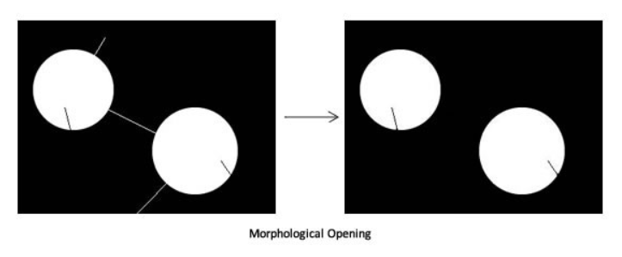

1. Closing
   1. Dilate then erode
   2. Closes up any narrow regions or holes in the image

